**Operation Fellah**

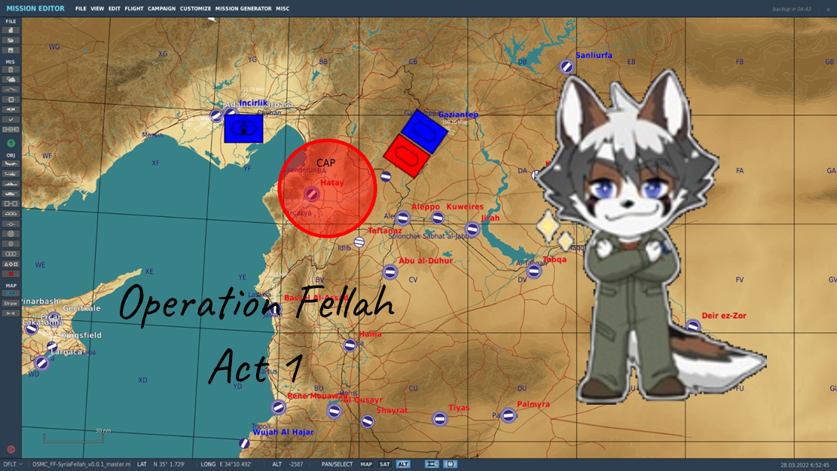

High Level concepts:

* We watch everything! We see every wasted warhead, we see every broken airframe
* Units need to get gassed up when they start, freedom isn’t free and neither is Jet Fuel A.
* IADS is installed (she be sneaky).
  + The system uses the EWR’s around the area to help build a picture of the threat picture. You will see threat rings on your displays but nothing on your RWR, that’s because the system is watching you with other radar facilities. Sam’s will activate when they think they can get a kill, and they will also go dark when they sense a HARM inbound.
    - SEAD & DEAD are going to be essential and effective because a HARM can buy you a few minutes to get other DEAD mentions to target.
* FAA Is not unlimited! (Fuel, Ammo, Airframes)
  + Pitched battle with a lot of activity is going to drain supplies more quickly as the activity ramps up. If you run out of supplies at your nearest supply point (truck, farp, airbase, etc) then you will need to have helos go pickup supplies from a production point and bring it back to your nearest supply point.
  + Fuel must come from primary refineries and delivered to airbases from top down.
  + Ammo must come from primary ammo production facilities.
  + Airframes are limited, the forces that Bluefor has brought in theater is what we have available. If there is a choice between the airframe and completing a mission the answer is going to almost always be the airframe, Forehead!
  + Theater command can at its discretion request a replenishment shipment.
  + 50 x F-16CM Blk 50
  + 50 x FA-18C
  + 50 X F-14 (Various)
  + 100 X AH-64D
  + 100 X UH-1H
  + Various other junk to use needed in a supply crisis (F-5’s, etc)
* Units destroyed in game will stay as statics (where applicable, for instance if you die on a road, you get swept to not block routing)
* Server restarts a next day every 4 hours of play time
* Weather is randomly generated every server start based on day/time (cold for winter, hot for summer, etc)
* Blue Force
  + Main base Incrilik
  + FARP ALPHA SW of Gaiztiaenenenenene (sp)
  + persistent Ewacs support will spawn if destroyed
  + persistent Tanker support will spawn if destroyed
  + CTLD will allow bluefor to build AA defenses as they take control of the map
    - This is different then hoggit style because as long as the cargo is dropped from the aircraft it will be retained on server reboot.
    - Sites you built will persist between restarts in the state they were in (they will not start 100% every time, so keep them repaired!)
    - Sling loading so you can use the Apache & Hinds for airlift logistics #battletaxi?
  + CSAR will create missions for helo pilots to rescue downed airfellas
    - Airfellas must eject to have a csar mission created.
    - Pilots should need to think more judiciously about ejection along with penalties for death.
* Redfor Forces
  + A midsized IADS has been setup on the syria map
  + Currently a single Northern CAP force
    - Random between Mig23,29,Su27,Su30,Su33 (1-2 ship)
  + Currently a single Northern Ground force
    - Random between small forces, to battalion level attacks towards FARP ALPHA
  + A smol fleet in area
  + Several Oil derricks can be hit to cripple redfor production
    - Destroying oil derricks will kill production (production not implemented yet)
* (coming) Scoreboard
  + will be tracked externally so it will persist with your tally of not only kills/deaths, but also fuel, weapon systems used over time.
  + Deaths will be major point penalties to your score, while ejections will not.

Sauce:  
<https://github.com/Fella-Flight/script-base>

Sausage:  
DSMC (Persist the world between restarts)

Moose   
- AI Package management  
- Scoreboard for tracking scoreboard over time

CTLD – Logistics (You build it!)  
CSAR – Search and Rescue (give helos some pilots to save)  
Restart on crash to restart world